Sales Performance Case Study – Sales Dataset (Mantra Data Labs)
1. Executive Summary
This case study presents a comprehensive sales performance analysis conducted by Mantra Data Labs for a national distributor using Microsoft Excel. The objective was to transform three years of transactional data (2022–2024) into a dynamic and interactive dashboard that enables management to monitor performance trends, evaluate category and brand growth, and assess the effectiveness of promotional activities.
The analysis focused on integrating large-scale sales records across multiple regions, channels, and product categories to identify the key drivers of business performance. Using Excel’s advanced functions, PivotTables, and visual analytics, the raw data was cleaned, structured, and translated into actionable insights.
2. Learning Objectives
- Clean and standardize retail transaction data using Power Query.
- Engineer new analytical features (Year, Month, Revenue).
- Build PivotTables and charts for category, brand, and regional performance.
- Design a professional one-page dashboard with slicers and KPI cards.
- Use Excel Copilot to accelerate data transformations and reporting.
3. Business Context

The client operates nationally across multiple regions and channels (Retail, E-commerce, Discount). Leadership needs a unified view of what’s selling, where, and how promotions and execution (stock, delivery) interact with sales. The deliverable is a dynamic Excel dashboard that updates automatically with new data, summarizes performance, and supports decisions on assortment, promotion design, and regional/channel strategy.
4. Prerequisites
- Excel (Microsoft 365 recommended), with Power Query and Pivot features enabled.
- (Optional) Excel Copilot for faster transformations and auto-summaries.
- Basic familiarity with PivotTables/Charts, slicers, and cell formulas.
5. Dataset Overview
Dataset Source period: 2022–2024 (Sales_Dataset)
Columns (used as-is):
- date (transaction date)
- sku, brand, segment, category, pack_type
- channel (Retail, E-commerce, Discount), region (PL-South/PL-North/PL-Central, etc.)
- price_unit (₹ per unit)
- units_sold, delivered_qty, stock_available, delivery_days
- promotion_flag (0/1)
Derived columns (added in Excel / Power Query):
- Year = YEAR([date])
- Month = MONTH([date])
- MonthName = TEXT([date],"mmm")
- revenue = units_sold * price_unit
Keep analysis faithful to these columns (we’re not inventing discount/profit measures).

6. Case Study Roadmap
- Power Query import & cleaning
- Feature engineering (Year/Month/MonthName, revenue)
- Pivot analysis (time, category/brand, region/channel, promotions, SKUs)
- Dashboard assembly (KPIs, charts, slicers)
- Insights & recommendations
- Deliverables & rubric

7. Step-by-Step Analysis in Excel

A) Import & Clean with Power Query
Steps
- Data → Get Data → From Excel Workbook → pick FMCG_2022_2024.xlsx.
- Use the First Row as Headers.
- Confirm types:
  - date → Date, numeric columns (price_unit, units_sold, delivered_qty, stock_available, delivery_days, promotion_flag) → Number.
- Add date parts: Add Column → Date → Year/Month/Month Name.
- Close & Load To… → Table on a sheet named CleanedData (or your existing sheet).
Prompt Help (Copilot)
“Detect wrong data types or blanks and suggest Power Query steps to fix them. Create Year, Month, and MonthName from the date column.”

B) Feature Engineering (in-grid)
Add columns to CleanedData:
Year = YEAR([@date])
Month = MONTH([@date])
MonthName = TEXT([@date],"mmm")
revenue = [@units_sold] * [@price_unit]

Format currency and thousands:
- Use Number Format → Currency (₹)
- For charts/labels in K/M: #,##0,," M" or #,##0," K".
Prompt Help (Copilot)
“Write formulas for Year, Month, MonthName, and revenue (units_sold × price_unit) and fill them down.”

C) Build the Core PivotTables & Charts
(Put each pivot on its own sheet; name sheets as below. You’ll paste chart screenshots into the doc.)
1) Monthly Trend — Sheet: 01_Time
Pivot:
- Rows: Year, MonthName
- Values: Sum of revenue, Sum of units_sold
Chart:
- Combo: revenue (columns) + units_sold (line), or revenue line.
- Format the value axis with K/M abbreviations.
Prompt Help (Copilot)
“Create a PivotTable summarizing revenue and units_sold by Year and MonthName. Add a combo chart with revenue as columns and units as a line.”
Output:
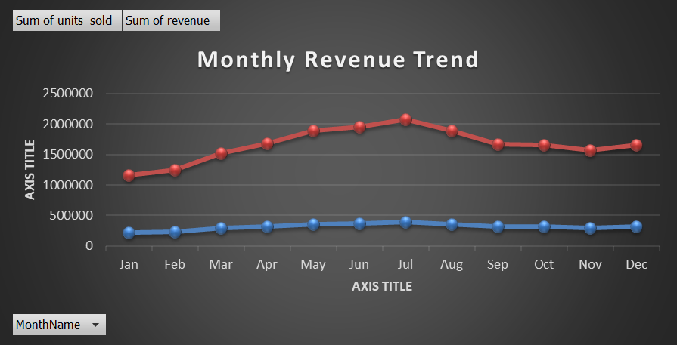

2) Category Performance — Sheet: 02_Category
Pivot:
- Rows: category
- Values: Sum of revenue, Sum of units_sold
- Sort by revenue (Largest → Smallest), filter Top 10.
Chart:
- Column chart “Top 10 Categories by Revenue”.
Prompt Help (Copilot)
“Build a pivot of revenue and units_sold by category, sort by revenue, keep Top 10, and add a clean column chart.”
Output:
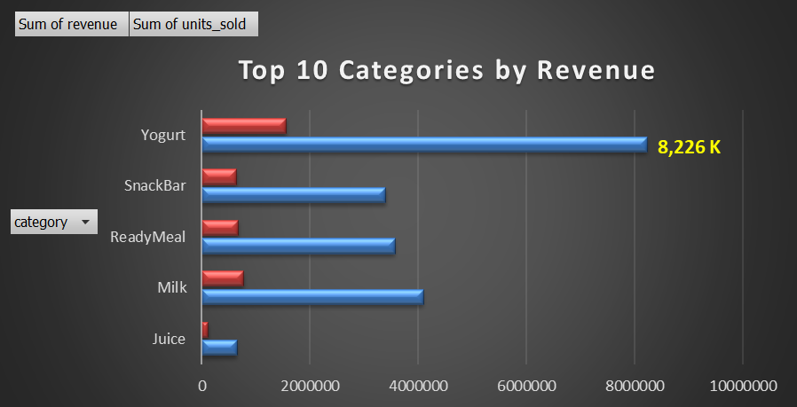

- Which categories have both low total revenue and low units sold during 2022–2024?
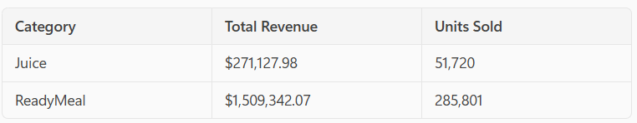

Suggestions to Improve Performance as per the Copilot

Juice
- Enhance marketing efforts to increase brand awareness.
- Introduce promotional discounts to boost sales.
- Evaluate product placement and availability across channels.
- Conduct customer surveys to understand preferences and improve offerings.

ReadyMeal
- Enhance marketing efforts to increase brand awareness.
- Introduce promotional discounts to boost sales.
- Evaluate product placement and availability across channels.
- Conduct customer surveys to understand preferences and improve offerings.

3) Brand Performance — Sheet: 03_Brand
Pivot:
- Rows: brand
- Values: Sum of revenue, Sum of units_sold
- Sort by revenue, show Top 10–15.
Chart:
- Column chart “Top Brands by Revenue”.
Prompt Help (Copilot)
“Create a brand revenue leaderboard chart with readable labels and thousands format.”
Output:
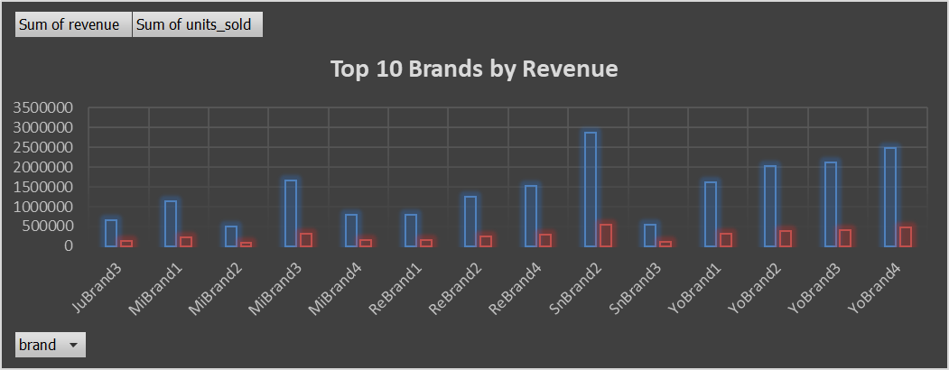

Brand Improvement Suggestions as per the Copilot:
- Strengthen visibility and promotions for low-performing brands.
- Introduce combo packs or limited-time offers to boost trial.
- Focus on channel-specific strategies — push stronger online presence for weaker brands.
- Refresh packaging and optimize product assortment to attract new customers.

4) Region Performance — Sheet: 04_Region
Pivot:
- Rows: region
- Values: Sum of revenue, Sum of units_sold
Chart:
- Pie chart “Revenue by Region”.
Prompt Help (Copilot)
“Build a region revenue pivot and add a Pie chart; format axis labels clearly.”
Output:
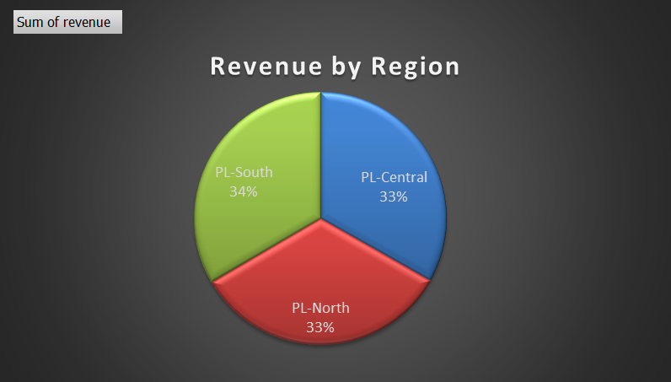

5) Channel Mix — Sheet: 05_Channel
Pivot:
- Rows: channel
- Values: Sum of revenue
Chart:
- Donut or bar chart “Revenue Share by Channel”.
Prompt Help (Copilot)
“Create a revenue share by channel chart with percentage data labels.”
Output:
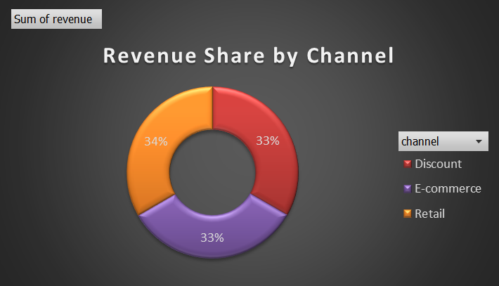

Suggestions Based on Findings as per the Copilot
- Targeted Promotions: Focus marketing efforts in regions or channels with the lowest performance to boost visibility.
- Product Placement Review: Evaluate shelf placement and visibility in underperforming channels.
- Customer Feedback: Collect feedback in low-performing regions to understand consumer preferences or barriers.
- Bundle Offers: Pair underperforming items with popular ones to increase uptake.
- Channel Strategy Adjustment: If a particular channel consistently underperforms, reassess its role in your distribution strategy.

6) Promotions — Sheet: 06_Promo
Pivot:
- Rows: MonthName (optionally nest Year above MonthName)
- Columns: promotion_flag (0/1)
- Values: Sum of revenue, Sum of units_sold, Average of price_unit
Chart:
- Clustered columns: Promo vs Non-Promo by month.
- Keep the interpretation careful (flag ≠ guaranteed discount).
Prompt Help (Copilot)
“Compare promo vs non-promo by month for revenue, units_sold, and avg price_unit, and add a clustered column chart.”
Output:
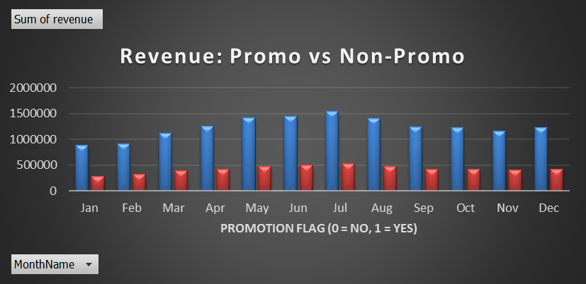

These SKUs have a promotion uplift ratio ≤ 1, indicating that promotions did not increase their sales.

Suggestions to Improve Promotional Impact as per the Copilot
- Reevaluate Promotion Type
Try different promotion formats (e.g., bundle offers, loyalty points, flash sales) that may better suit the product category or customer behavior.
- Targeted Marketing
Use customer segmentation to tailor promotions to audiences more likely to respond to these products.
- Product Placement & Visibility
Enhance in-store or online visibility during promotions—e.g., featured listings, end-cap displays, or homepage banners.
- Review Product Fit
Some products may not benefit from promotions due to low demand elasticity. Consider focusing promotional efforts on more responsive items.
- Test and Learn
Run A/B tests with different promotional strategies to identify what works best for each SKU.

7) SKU Leaderboard — Sheet: 07_SKU
Pivot:
- Rows: sku (optionally include brand, category beneath)
- Values: Sum of revenue, Sum of units_sold
- Sort by revenue; keep Top 20.
Chart:
- Horizontal bar chart “Top 20 SKUs by Revenue”.
Prompt Help (Copilot)
“Create a Top-20 SKUs chart by revenue with clean labels and thousands formatting.”
Output:
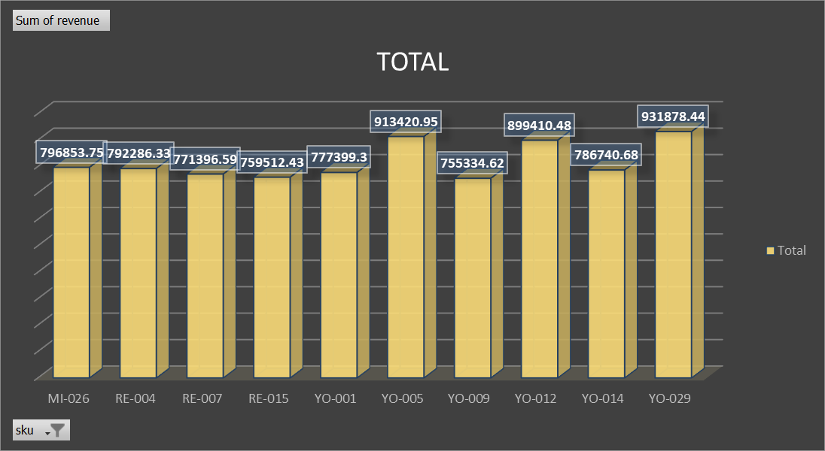

- Which brands or SKUs generate low revenue per unit sold, indicating weak pricing or low profitability? Give Suggestions (Copilot)
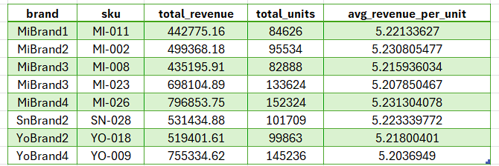

Suggestions for Improvement as per the Copilot
- Reevaluate Pricing Strategy
These SKUs may be underpriced relative to their value or market demand. Consider:
  - Competitive benchmarking
  - Value-based pricing models
- Cost Optimization
If pricing adjustments aren't feasible, explore ways to reduce production or distribution costs to improve margins.
- Product Differentiation
Enhance perceived value through packaging, features, or bundling to justify higher prices.
- Targeted Promotions
Use promotions to increase volume selectively while monitoring profitability impact.
- SKU Rationalization
If certain SKUs consistently underperform, consider phasing them out or replacing them with higher-margin alternatives.

D) Build the Retail Dashboard Sheet
Layout (recommended 2–3 column grid):
Top row (KPI cards):
- Total Revenue (linked to Yearly totals):
=SUM(Yearly!B:B) or use GETPIVOTDATA from your Yearly pivot.
- Total Units Sold: =SUM(Yearly!C:C)
Sales Growth %:
=(SUMIFS(Yearly!B:B,Yearly!A:A,MAX(Yearly!A:A)) -SUMIFS(Yearly!B:B,Yearly!A:A,MIN(Yearly!A:A)))
/SUMIFS(Yearly!B:B,Yearly!A:A,MIN(Yearly!A:A))

- Number formats: K/M for currency, 0.0% for growth.
- Light yellow cards, subtle borders, bold headings.
Total Revenue |  |  | Total Units Sold | Sales Growth %
39.9 M |  |  | 7.6 M | 163.6%

Middle panels:
- Monthly Revenue Trend (from 01_Time)
- Revenue by Region (from 04_Region)
- Top Categories / Top Brands (from 02_Category / 03_Brand)
- Revenue Share by Channel (from 05_Channel)
- Promo vs Non-Promo (from 06_Promo)
Slicers:
- Insert slicers for Year, category, brand, region, channel, promotion_flag.
- Report Connections / PivotTable Connections → select all pivots so slicers filter everything.
Bottom:
- Insights / Notes box (text), where you summarize key takeaways.
Prompt Help (Copilot)
“Design an executive dashboard with KPI cards (Total Revenue, Total Units, Sales Growth%), monthly trend, region, category/brand, channel share, and promo comparison. Place slicers for Year, category, brand, region, channel, and promotion_flag and connect them to all pivots.”
(If you prefer automation, run the VBA macro we shared earlier to build the entire sheet programmatically.)

Dashboard Link: Retail_Dashboard

8. Diagnostic Analysis: Low-Performing Categories and Products
To extend the analysis beyond top-line trends, the next step is to identify categories and brands that are underperforming — those with low revenue, low sales volume, or weak price realization (revenue per unit).
This helps business teams take corrective actions such as optimizing pricing, revising promotions, or streamlining product portfolios.

Key Business Questions you can ask for Copilot
- Which categories have both low total revenue and low units sold during 2022–2024?Suggestions
- Which brands or SKUs generate low revenue per unit sold, indicating weak pricing or low profitability?Suggestions
- Are there specific regions or channels where these underperforming categories are concentrated?Suggestions
- Which products remain unresponsive to promotions, showing no uplift during promotional periods?Suggestions

8. Insights and Recommendations
What we see
- Growth: Revenue rose ~164% (2022→2024). Units also grew → real demand expansion.
- Category engine: Yogurt dominates (≈ ₹8.23M). Milk and ReadyMeal form the second tier.
- Brands: SnBrand2, YoBrand4, YoBrand3, YoBrand2 lead.
- Region: PL-South slightly ahead; others close—healthy diversification.
- Channel: Retail, E-com, Discount are near-equal contributors (Retail marginally higher).
- Promotions: promotion_flag rows show lower totals and little price change vs non-promo. Treat the flag as a campaign marker and measure uplift per day against same-period last year.
What to do
- Double-down on Yogurt: Defend hero SKUs; expand flavors/packs online (E-com premiumization).
- Promo redesign & measurement:
  - Run A/B by weeks; compare units/day and revenue/day vs same weeks LY.
  - Prioritize shallower, targeted offers for hero SKUs; avoid deep discounting on already fast movers.
- Channel-specific pack architecture:
  - Discount → family/value packs; protect margin.
  - E-com → premium bundles and rapid new-SKU trials.
  - Retail → core multipacks and impulse displays.
- Ops guardrails:
  - Maintain delivery_days ≤ 3, especially during peaks.
  - Set min-stock thresholds for Top-20 SKUs by region/channel.

9. Final Deliverables
- Cleaned Excel workbook (Power Query steps, derived columns included).
- Pivot analysis sheets: 01_Time, 02_Category, 03_Brand, 04_Region, 05_Channel, 06_Promo, 07_SKU.
- Retail Dashboard sheet (KPI cards, charts, slicers, Notes).
- Short insights deck (or notes in the dashboard) summarizing key findings & actions.

10. Evaluation Rubric

Criteria | Description | Weight
Data Prep & Quality | Correct types, derived fields, no obvious errors | 20%
Pivot Analysis Depth | Time, mix, promo, SKU views; correct filters | 25%
Dashboard Design | Clear layout, slicers connected, K/M labels | 25%
Copilot Use | Effective prompts for speed/clarity | 10%
Insights & Actions | Evidence-based, feasible recommendations | 20%

11. Conclusion
The retailer’s growth through 2022–2024 is broad-based and sustainable, anchored by Yogurt and a handful of leading brands and SKUs. The balanced channel mix reduces risk, while regional parity shows healthy footprint breadth.
Promotions, as currently flagged, do not correlate with uplift; the right next step is a structured, like-for-like promo measurement framework and tighter pack/price strategies by channel. Operationally, maintaining ~3-day delivery and safety stock on hero SKUs will protect the growth trajectory.
12. Appendix: Formula References
Year = YEAR([@date])
Month = MONTH([@date])
MonthName = TEXT([@date],"mmm")
Revenue = [@units_sold]*[@price_unit]
KPI cells (on Dashboard)
Total Revenue = SUM(Yearly!B:B)
Total Units Sold = SUM(Yearly!C:C)

Sales Growth % = ( SUMIFS(Yearly!B:B,Yearly!A:A,MAX(Yearly!A:A))
- SUMIFS(Yearly!B:B,Yearly!A:A,MIN(Yearly!A:A)) )
/ SUMIFS(Yearly!B:B,Yearly!A:A,MIN(Yearly!A:A))
Number formats for labels
- Thousands (K): #,##0," K" or #,##0.0," K"
- Millions (M): #,##0,," M" or #,##0.00,," M"

